** HUMAN BIOLOGICAL SCIENCE**

**Stage 1**

**Semester One Examination 2016**

Student Name:

Teacher:

**Time allowed for this paper**

Reading time before commencing work: Ten minutes

Working time for paper: 2 hours 30 minutes

**Materials required/recommended for this paper**

To be provided by the supervisor

**Multiple-choice Answer sheet**

**This Question/Answer Booklet**

***To be provided by the candidate***

**Standard items:** pens (blue/black preferred), pencils (including coloured), sharpener, correction tape/fluid, eraser, ruler, highlighters

**Special items:** non-programmable, non-graphics calculators approved for use in the WACE examinations

**Important note to candidates**

No other items may be taken into the examination room. It is your responsibility to ensure that you do not have any unauthorised notes or other items of a non‑personal nature in the examination room. If you have any unauthorised material with you, hand it to the supervisor before reading any further.

***Structure of this paper***

|  |  |  |  |  |  |
| --- | --- | --- | --- | --- | --- |
| Section | Suggested working time | Number of questions available | Number of questions to be attempted | Marks | Percentage |
| SECTION ONE:  Multiple-choice | 40 minutes | 30 | All | 30 | 30 |
| SECTION TWO:  Short answers | 70 minutes | 7 | All | 100 | 50 |
| SECTION THREE:  Extended answers | 40 minutes | 3 | 2 | 40 | 20 |
|  |  |  | Total marks | 170 | 100 |

**Instructions to candidates**

1. The rules for the conduct of Western Australian external examinations are detailed in the *Year 12 Information Handbook 2016.* Sitting this examination implies that you agree to abide by these rules.

2. Answer the questions according to the following instructions.

Section One: Answer all questions on the separate Multiple-choice Answer Sheet provided. For each question shade the box to indicate your answer. Use only a blue or black pen to shade the boxes. If you make a mistake, place a cross through that square, do not erase or use correction fluid, and shade your new answer. Marks will not be deducted for incorrect answers. No marks will be given if more than one answer is completed for any question.

Sections Two and Three: Write your answers in this Question/Answer Booklet.

3. You must be careful to confine your responses to the specific questions asked and to follow any instructions that are specific to a particular question.

4. Spare pages are included at the end of this booklet. They can be used for planning your responses and/or as additional space if required to continue an answer.

* Planning: If you use the spare pages for planning, indicate this clearly at the top of the page.
* Continuing an answer: If you need to use the space to continue an answer, indicate in the original answer space where the answer is continued, i.e. give the page number. Fill in the number of the question(s) that you are continuing to answer at the top of the page.

**Section One: Multiple-choice 30% (30 Marks)**

This section has **30** questions. Answer **all** questions on the separate Multiple-choice Answer Sheet provided. For each question shade the box to indicate your answer. Use only a **blue or black pen** to shade the boxes. If you make a mistake, place a cross through that square, do not erase or use correction fluid, and shade your new answer. Marks will not be deducted for incorrect answers. No marks will be given if more than one answer is completed for any question.

Suggested working time: 40 minutes.

1. In an experiment, measurements are made and the results are recorded in a table. Sometimes there are numbers that are well beyond the range of the rest of the measurements. Such numbers are referred to as

(a) trials.

(b) outliers.

(c) mean averages.

(d) mode averages.

1. A person weighing 115 kg lost 4 kg in a month. What was the percentage decrease of their weight?
2. 7.2%
3. 115%
4. 28.75%
5. 3.47%

**Look at the results table below and answer the question that follows.**

|  |  |
| --- | --- |
| **Temperature ( ̊C)** | **Enzyme Activity (mg of maltose produced)** |
| 10 | 4 |
| 15 | 7.5 |
| 20 | 11 |
| 25 | 14 |
| 30 | 17 |
| 35 | 19 |
| 37 | 23 |
| 40 | 22 |
| 45 | 18 |

1. What type of data is shown and which graph would best represent this data?
2. Discontinuous and bar graph
3. Discontinuous and line graph
4. Continuous and line graph
5. Continuous and bar graph
6. The cell theory could best be described as
7. all living organisms are made up of cells and materials produced by cells.
8. all living organisms are made up of cells and progressively become more complex.
9. the structure of all living organisms and the way they function result from the activity of all its cells.
10. all living organisms cells are small so they can exchange materials effectively.
11. If the concentration of sugar in the solution outside a cell is 10% and inside the cell the concentration of sugar is 0.9%. The cell would;
12. Expand and burst
13. Shrivel up
14. Retain its normal shape
15. Lose its sugar content
16. When body systems work together to make sure the cellular environment is kept constant, this is known as
17. cellular respiration.
18. endocytosis.
19. homeostasis.
20. pinocytosis.
21. The two types of carrier-mediated transport are
22. diffusion and osmosis.
23. diffusion and endocytosis.
24. facilitated transport and active transport.
25. facilitated diffusion and osmosis.
26. Phagocytosis is best represented as which of the following transfer mechanisms?
27. Active transport
28. Exocytosis
29. Pinocytosis
30. Endocytosis
31. Which of the following lists best shows the levels of structural organisation of the human body?
32. Atoms, Molecules, Tissues, Organs
33. Cells, Tissues, Organs, Systems
34. Molecules, Atoms, Cells, Tissues
35. Molecules, Tissues, Organs, Systems
36. Which of the following lists best describe the smallest parts of a carbohydrate and a lipid, respectively?
37. Monosaccharides and Triglycerides and fatty acids.
38. Monosaccharides and Triglycerides and nucleic acids
39. Saccharides and Triglycerides and fatty acids.
40. Polysaccharides and amino acids.

**Use the diagram below of a nephron and its associated blood supply to answer the following TWO questions.**

A

B

C

D

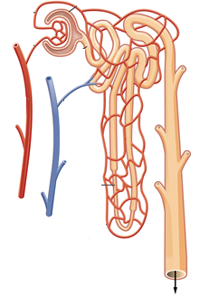

E

F

1. The proximal convoluted tubule is indicated by label
2. A.
3. B.
4. C.
5. D.
6. Glomerular filtration would involve structure(s) labelled
7. A.
8. A and B.
9. D.
10. D and E.
11. Which of the following chemical equations shows the process of deamination?
12. Ammonia + carbon dioxide + energy 🡪 urea + water
13. Oxygen + carbohydrate 🡪 energy + water + carbon dioxide
14. Oxygen + lipid 🡪 carbohydrate + ammonia
15. Amino acid + oxygen 🡪 carbohydrate + ammonia
16. What is present on the surface of rough endoplasmic reticulum?
17. vesicles
18. golgi bodies
19. ribosomes
20. centrioles
21. The white blood cell, red blood cell and platelet, could also be referred to as respectfully:
22. Erythrocyte, leucocyte and thrombocyte.
23. Thrombocyte, leucocyte and erythrocyte.
24. Leucocyte, thrombocyte and erythrocyte.
25. Leucocyte, erythrocyte and thrombocyte.
26. Carbon dioxide is carried in a number of ways in the blood. Which of the following methods carries the most in the blood?
27. The carbon dioxide is dissolved in the plasma.
28. The carbon dioxide binds to haemoglobin to form carbaminohaemoglobin.
29. The carbon dioxide is carried in the plasma as bicarbonate ions.
30. The carbon dioxide is carried in the plasma as hydrogen ions.
31. Which valve is located between the right atrium and right ventricle
32. pulmonary semilunar valve
33. tricuspid
34. bicuspid
35. aortic semilunar valve
36. Which of the lists **BEST** describe the **sequential** order of vessels that blood would flow through?
37. Capillary, venule, artery
38. Aorta, capillary, vein
39. Capillary, vein, vena cava
40. Arteriole, capillary, venule

1. A blood sample was mixed with plasma that contained Anti-A and, in a separate test, with plasma containing Anti-B. The blood sample coagulated in the presence of the Anti–A but NOT in the presence of the Anti-B.

The blood sample could be classified into which of the following blood groups?

1. blood type B
2. blood type A
3. blood type O
4. blood type AB
5. Which of the following is NOT a problem associated with the respiratory system?
6. asthma
7. bronchitis
8. pneumonia
9. meningitis
10. Which of the following substances are NOT secreted by cells in a gastric gland?
11. mucus
12. pepsinogen
13. trypsin
14. hydrochloric acid
15. Which of the following respiratory disorders is NOT contagious?
16. influenza
17. pneumonia
18. emphysema
19. tuberculosis
20. The gall bladder stores which chemical and releases it into which organ respectively?
21. gastric juice and duodenum
22. bile and stomach
23. gastric protease and duodenum
24. bile and duodenum
25. The removal of metabolic wastes from the body is best described as
26. elimination.
27. defecation.
28. asphyxiation.
29. excretion.
30. People with coeliac disease are unable to tolerate a protein called gluten. The only treatment is to follow a gluten-free diet. Which of the following foods should a person with coeliac disease avoid?
31. dairy products
32. wheat based products
33. rice based products
34. carbohydrates
35. As substances in the proximal convoluted tubule of the kidney are reabsorbed they move from
36. peritubular capillaries to filtrate, to epithelial cells, to interstitial fluid
37. peritubular capillaries to filtrate, to interstitial fluid, to epithelial cells
38. filtrate to peritubular capillaries, to epithelial cells, to interstitial fluid
39. filtrate to epithelial cells , to interstitial fluid, to peritubular capillaries

27. As blood flows through the glomerulus

1. most plasma proteins are transferred to the glomerular capsule
2. about 20% of plasma is filtered into the glomerular capsule
3. its plasma volume increases as fluid enters from the glomerular capsule
4. about 20% of the red blood cells pass into the glomerular capsule

28. Reabsorption of sodium by the kidney occurs in the

1. proximal and distal convoluted tubule only
2. proximal and distal convoluted tubules and loop of Henle
3. loop of Henle only
4. distal convoluted tubule and collecting duct

29. Intestinal absorption of some substances is an active process. This means that:

1. the villi must actually move to enable molecules of food to be absorbed by pinocytosis
2. products of digestion diffuse quickly across the membranes
3. energy is expended for the absorption of some substances against a concentration gradient
4. the absorption of some substances occurs most readily when there is maximum movement of the intestines.

30. The function of the pleural membrane is to:

1. hold the lungs in their correct position in the thoracic cavity
2. help to increase the volume of the thoracic cavity during respiration
3. secrete a fluid enabling the lungs to expand and contract with the thoracic wall
4. help the diaphragm to increase or decrease the volume of the thoracic cavity

**End of Section One**

**Section Two: Short answer 50% (100 Marks)**

This section has **seven (7)** questions. Answer **all** questions. Write your answers in the spaces provided.

Spare pages are included at the end of this booklet. They can be used for planning your responses and/or as additional space if required to continue an answer.

* + Planning: If you use the spare pages for planning, indicate this clearly at the top of the page.
  + Continuing an answer: If you need to use the space to continue an answer, indicate in the original answer space where the answer is continued, i.e. give the page number. Fill in the number of the question(s) that you are continuing to answer at the top of the page.

Suggested working time: 70 minutes.

**Question 31 (13 marks)**

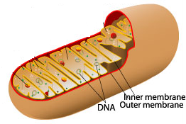

### Identify the organelle above. ____________________________________ (1 mark)

### Skeletal muscle cells contain many of these organelles. Explain why this is the case.

____________________________________________________________________________________________________________________________________________________________________________________________________________________________________________________________________________________

(3 marks)

1. Using either a word or chemical equation, describe the chemical reaction that would occur within the organelle above and explain how this can result in the formation of ATP.

________________________________________________________________________________________________________________________________________________________________________________________________________________________________________________________________________________________

(2 marks)

The following hypothetical cells are cuboidal in shape, with the length, breadth and heights as indicated.

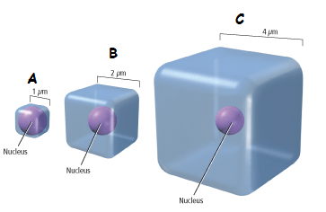

1. Which of the cells in the diagram above (A, B or C) would have the **smallest** surface area to volume ratio?

______________________________________________________________________

(1 mark)

1. Which of the cells in the diagram above (A, B or C) would supply its organelles with the substances they require most efficiently? Explain your reasoning.

________________________________________________________________________________________________________________________________________________________________________________________________________________________________________________________________________________________

______________________________________________________________________

(4 marks)

1. Name two (2) inputs and two (2) outputs of typical animal cells.

Inputs ______________________________________________________________

Outputs ____________________________________________________________

(2 marks)

**Question 32 (15 marks)**

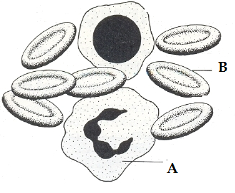

1. Looking at the picture above, state which of the four main tissue types is being shown.

__________________________________________________________________

(1 mark)

1. Provide a reason for your answer in part (a).

__________________________________________________________________

__________________________________________________________________

(1 mark)

1. Identify each of these cells and state their basic function.
2. ___________________

Function: __________________________________________________________

1. ___________________

Function: __________________________________________________________

(4 marks)

1. Describe three (3) reasons why the cells labelled with a “B” in the picture above are well suited to their function.

__________________________________________________________________ __________________________________________________________________

__________________________________________________________________ __________________________________________________________________

__________________________________________________________________ __________________________________________________________________ __________________________________________________________________

(6 marks)

1. With reference to the lymphatic system, explain why exercising can reduce the chances of you getting a bacterial infection.

(3 marks)

________________________________________________________________________________________________________________________________________________________________________________________________________________________________________________________________________________________________________________________________________________________________________________________________________________________

**Question 33 (15 marks)**

The diagram shown below is a representation of the human digestive system.

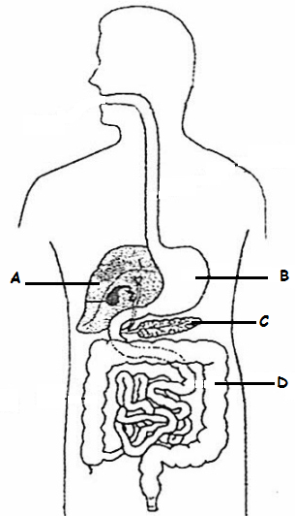

1. State one (1) function for each of the parts listed in the above diagram. (4 marks)

A: _______________________________________________________________

B:

C: ________________________________________________________________

D: ________________________________________________________________

1. Chinese swimmer Sun Yang holds the world record for the 1500m men’s freestyle with a time of 14 minutes and 31 seconds. Detail the main cellular respiration system that he would rely on during the race.

(5 marks)

**INTENTIONALLY LEFT BLANK**

**The** **diagrams below show structures found in the small intestine and lungs.**

Structural Feature 1 Structural Feature 2

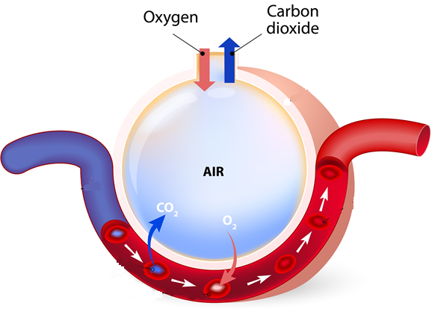

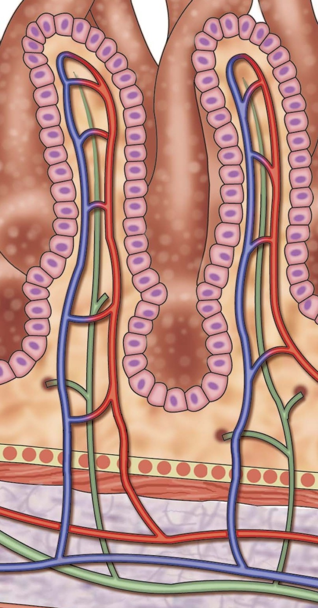

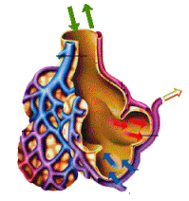

The exchange surfaces of the small intestine and lungs rely on concentration differences so that substances can cross the surfaces rapidly and constantly.

(c) Identify structural features 1 and 2 and describe four (4) similarities that allow them to

maintain the concentration gradient.

(6 marks)

**Question 34 (15 marks)**

This question refers to the diagram shown below.

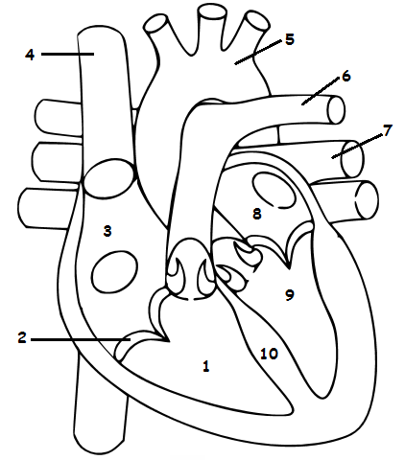

1. Identify the above labeled structures:

|  |
| --- |
| 1. |
| 2. |
| 7. |
| 8. |
| 10. |

(5 marks)

1. What are the functions of structures 2, 5 and 6?

2. ___________________________________________________________________

5. ___________________________________________________________________

6. ___________________________________________________________________

(3 marks)

1. Label all the veins and arteries on the diagram above, with a “V” and an “Ar” respectively.

(2 marks)

1. How does the heart muscle receive nutrients and remove metabolic wastes?

____________________________________________________________________________________________________________________________________________________________________________________________________________________________________________________________________________________

(2 marks)

1. Arteries differ in structure and function to that of the veins.

Give two (2) structural differences and one (1) functional difference between arteries and veins.

Structural difference 1 ________________________________________________

__________________________________________________________________

Structural difference 2 ________________________________________________

__________________________________________________________________

Functional difference _________________________________________________

__________________________________________________________________

(3 marks)

**Question 35 (10 marks)**

Study the diagram below and answer the questions that follow.

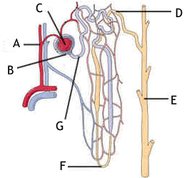

1. Provide labels for structures:

A __________________________

B __________________________

E __________________________

F __________________________

(4 marks)

1. Briefly explain how the afferent arteriole and efferent arteriole assist Structure C to carry out its function.

_______________________________________________________________________________________________________________________________________________________________________________________________________________

(2 marks)

Water is reabsorbed via the cells that line the whole length of the nephron. The method of transport used to absorb the water in the proximal convoluted tubule (PCT) and Loop of Henle is different to the method used in the distal convoluted tubule (DCT) and collecting duct (CD).

1. State which of the four tissue types the cells of the DCT are classified into.

__________________________________________________________________________________________________________________________________________ (1 mark)

1. Explain how water molecules move from the PCT and Loop of Henle into the blood stream.

____________________________________________________________________________________________________________________________________________________________________________________________________________________________________________________________________________________

(3 marks)

**Question 36 (20 marks)**

In the 1960’s a doctor working for the Red Cross in the Congo region of Africa, saw pregnant women drinking tea from the leaves of the Kalata-Kalata plant. These women believed that drinking the tea increased the speed at which they gave birth.

Scientist later discovered that a protein (named Kalata B1) in the leaf caused the contractions of the uterus in women. In an effort to help women who were overdue, scientists wanted to find out what concentration of Kalata B1 was needed to start contractions in women, who were in their 41st week of pregnancy, as soon as possible after consuming the tea.

Five different concentrations of Kalata B1were tested. Each concentration was tested on 5 different women, who were all tested in the one hospital.

The results from this experiment can be seen below.

|  |  |  |  |  |  |  |
| --- | --- | --- | --- | --- | --- | --- |
| Concentration of Kalata B1 (g/mL) | Time elapsed before contractions started (seconds) | | | | | |
| Trials | | | | |  |
| 1 | 2 | 3 | 4 | 5 | Average |
| 0.01 | 35 000 | 38 000 | 36 500 | 33 240 | 37 005 | 35 949 |
| 0.02 | 28 000 | 27 000 | 26 980 | 29 009 | 27 101 | 27 618 |
| 0.03 | 26 000 | 27 809 | 25 807 | 26 500 | 27 709 | 26 765 |
| 0.04 | 23 000 | 22 908 | 23 776 | 22 809 | 23 005 | 23 100 |
| 0.05 | 18 000 | 17 986 | 18 203 | 18 246 | 18 009 |  |

1. Write a suitable hypothesis for this experiment. (1 mark)

_______________________________________________________________________________________________________________________________________________________________________________________________________________

1. Name the:

(i) Independent variable __________________________________

(ii) Dependent variable ___________________________________ (2 marks)

1. Calculate the average time elapsed for the 0.05 g/mL Kalata B1 concentration and place it in the table above. (1 mark)
2. Plot the average results on the graph paper supplied on the next page.

(5 marks)

|  |  |  |  |  |  |  |  |  |  |  |  |  |  |  |  |  |  |
| --- | --- | --- | --- | --- | --- | --- | --- | --- | --- | --- | --- | --- | --- | --- | --- | --- | --- |
|  |  |  |  |  |  |  |  |  |  |  |  |  |  |  |  |  |  |
|  |  |  |  |  |  |  |  |  |  |  |  |  |  |  |  |  |  |
|  |  |  |  |  |  |  |  |  |  |  |  |  |  |  |  |  |  |
|  |  |  |  |  |  |  |  |  |  |  |  |  |  |  |  |  |  |
|  |  |  |  |  |  |  |  |  |  |  |  |  |  |  |  |  |  |
|  |  |  |  |  |  |  |  |  |  |  |  |  |  |  |  |  |  |
|  |  |  |  |  |  |  |  |  |  |  |  |  |  |  |  |  |  |
|  |  |  |  |  |  |  |  |  |  |  |  |  |  |  |  |  |  |
|  |  |  |  |  |  |  |  |  |  |  |  |  |  |  |  |  |  |
|  |  |  |  |  |  |  |  |  |  |  |  |  |  |  |  |  |  |
|  |  |  |  |  |  |  |  |  |  |  |  |  |  |  |  |  |  |
|  |  |  |  |  |  |  |  |  |  |  |  |  |  |  |  |  |  |
|  |  |  |  |  |  |  |  |  |  |  |  |  |  |  |  |  |  |
|  |  |  |  |  |  |  |  |  |  |  |  |  |  |  |  |  |  |
|  |  |  |  |  |  |  |  |  |  |  |  |  |  |  |  |  |  |
|  |  |  |  |  |  |  |  |  |  |  |  |  |  |  |  |  |  |
|  |  |  |  |  |  |  |  |  |  |  |  |  |  |  |  |  |  |
|  |  |  |  |  |  |  |  |  |  |  |  |  |  |  |  |  |  |
|  |  |  |  |  |  |  |  |  |  |  |  |  |  |  |  |  |  |
|  |  |  |  |  |  |  |  |  |  |  |  |  |  |  |  |  |  |
|  |  |  |  |  |  |  |  |  |  |  |  |  |  |  |  |  |  |
|  |  |  |  |  |  |  |  |  |  |  |  |  |  |  |  |  |  |
|  |  |  |  |  |  |  |  |  |  |  |  |  |  |  |  |  |  |

1. Two groups should be used in any experiment. State the name of the two groups and explain how they are different to each other.

____________________________________________________________________________________________________________________________________________________________________________________________________________________________________________________________________________________

1. marks)
2. A placebo should have been used as this experiment was trialing a drug.

Define what a placebo is and describe how it should have been used in this experiment.

_______________________________________________________________________________________________________________________________________________________________________________________________________________

(3 marks)

1. Excluding the placebo, name a controlled variable that was used in this experiment and explain why it was used.

_______________________________________________________________________________________________________________________________________________________________________________________________________________

(2 marks)

1. The same factors that influence the activities of enzymes, affect proteins.

Explain two (2) reasons why scientists were amazed that the Kalata B1 protein remained active and had an effect on the women’s uterus.

_________________________________________________________________________________________________________________________________________________________________________________________________________________________________________________________________________________________________________________________________________________________

(3 marks)

**Question 37** (12 marks)

1. Fill in the table showing the basic units of the nutrients listed

|  |  |
| --- | --- |
| Nutrient | Basic units |
| Carbohydrate |  |
| Protein |  |
| Lipids |  |

(3 marks)

1. Foods such as white bread and pasta are predominantly composed of complex carbohydrates. Explain how your digestive system breaks down these complex carbohydrates chemically. Include in your answer the structures and specific enzymes involved. _____________________________________________________________________________________________________________________________________________________________________________________________________________________________________________________________________________________________________________________________________________________________________________________________________________________________________________________________________________________________________________________________________________________________________________________________________________________________________________

(5 marks)

1. Distinguish between the processes of excretion and elimination and list one organ involved in each process. ______________________________________________________________________________________________________________________________________________________________________________________________________________________________________________________________________________________________________________________________________________________________________________________________________________________________

(4 marks)

**End of Section Two**

**Section Three: Extended answer 20% (40 Marks)**

This section contains **three (3)** questions. You must answer **two (2)** questions. Make sure you clearly indicate which question you are answering and write your answers in the space provided.

Spare pages are included at the end of this booklet. They can be used for planning your responses and/or as additional space if required to continue an answer.

* + Planning: If you use the spare pages for planning, indicate this clearly at the top of the page.
  + Continuing an answer: If you need to use more space to continue an answer, indicate in the original answer space where the answer is continued, i.e. give the page number. Write the number of the question(s) that you are continuing to answer at the top of the additional space page.

Responses could include clearly labelled diagrams with explanatory notes; lists of points with linking sentences; clearly labelled tables and graphs; and annotated flow diagrams with introductory notes.

Suggested working time: 40 minutes.

**Question 38 (20 marks)**

1. Draw and label the structures that have a role in the movement of air into the lungs.

(5 marks)

1. A common war injury is the “Sucking chest” wound. This is where shrapnel or a bullet has penetrated the victim’s sternum and pleura. A hissing sound can be heard as the person attempts to breathe. This injury can be fatal within a few minutes, as their lung(s) will collapse.

Describe the process that normally occurs to increase and decrease the volume of the chest cavity during inspiration and expiration and explain why a “Sucking chest” wound would make breathing physically impossible and cause the collapse of the affected lung.

(10 marks)

1. Describe the process that can lead to the development of a “smoker’s cough” and explain how the “smoker’s cough” can lead to the sufferer developing emphysema. Explain why the sufferer needs to consciously make an effort to exhale.

(5 marks)

**Question 39 (20 marks)**

Unlike single celled organisms such as amoeba, the human body has a very complex circulatory system that deals with the delivery and removal of many substances to and from the body.

1. Explain how the our circulatory system delivers oxygen and nutrients to and removes wastes from the cells of the human body

(12 marks)

1. Use a summary of the ABO and Rh blood groups, showing the antigens and antibodies present in each group, to explain why an adverse reaction occurs when incompatible blood types are mixed. State why people with blood type O negative can donate their blood to anyone, whereas people with blood type AB positivecan receive blood from anyone.

(8 marks)

**Question 40 (20 marks)**

There are six main methods in which materials are transported across cell membranes.

1. Describe how four (4) of these methods occur, the type of material that is transferred and a specific example of where it occurs in the body.

(12 marks)

1. There are three main processes that occur in a nephron; filtration, selective reabsorption and tubular secretion. Briefly describe each of these processes and how each contributes to the final composition of urine

(8 marks)

**End of questions.**

Question number: ________________

________________________________________________________________________________________________________________________________________________________________________________________________________________________________________________________________________________________________________________________________________________________________________________________________________________________________________________

________________________________________________________________________________________________________________________________________________________________________________________________________________________________________________________________________________________________________________________________________________________________________________________________________________________________________________

________________________________________________________________________________________________________________________________________________________________________________________________________________________________________________________________________________________________________________________________________________________________________________________________________________________________________________

________________________________________________________________________________________________________________________________________________________________________________________________________________________________________________________________________________________________________________________________________________________________________________________________________________________________________________

________________________________________________________________________________________________________________________________________________________________________________________________________________________________________________________________________________________________________________________________________________________________________________________________________________________________________________________________________________________________________________________________________________________________________________________________________________________________________________________________________________________________________________________________________________

Question number: ________________

________________________________________________________________________________________________________________________________________________________________________________________________________________________________________________________________________________________________________________________________________________________________________________________________________________________________________________________________________________________________________________________

________________________________________________________________________________________________________________________________________________________________________________________________________________________________________________________________________________________________________________________________________________________________________________________________________________________________________________

________________________________________________________________________________________________________________________________________________________________________________________________________________________________________________________________________________________________________________________________________________________________________________________________________________________________________________

________________________________________________________________________________________________________________________________________________________________________________________________________________________________________________________________________________________________________________________________________________________________________________________________________________________________________________

________________________________________________________________________________________________________________________________________________________________________________________________________________________________________________________________________________________________________________________________________________________________________________________________________________________________________________________________________________________________________________________________________________________________________________________________________________________________________________________________________

Question number: ________________

________________________________________________________________________________________________________________________________________________

________________________________________________________________________

________________________________________________________________________________________________________________________________________________________________________________________________________________________________________________________________________________________________________________________________________________________________________________________________________________________________________________

________________________________________________________________________________________________________________________________________________________________________________________________________________________________________________________________________________________________________________________________________________________________________________________________________________________________________________

________________________________________________________________________________________________________________________________________________________________________________________________________________________________________________________________________________________________________________________________________________________________________________________________________________________________________________

________________________________________________________________________________________________________________________________________________________________________________________________________________________________________________________________________________________________________________________________________________________________________________________________________________________________________________

________________________________________________________________________________________________________________________________________________________________________________________________________________________________________________________________________________________________________________________________________________________________________________________________________________________________________________________________________________________________________________________

Question number: ________________

________________________________________________________________________________________________________________________________________________________________________________________________________________________

________________________________________________________________________

________________________________________________________________________________________________________________________________________________________________________________________________________________________________________________________________________________________________________________________________________________________________________________________________________________________________________________

________________________________________________________________________________________________________________________________________________________________________________________________________________________________________________________________________________________________________________________________________________________________________________________________________________________________________________

________________________________________________________________________________________________________________________________________________________________________________________________________________________________________________________________________________________________________________________________________________________________________________________________________________________________________________

________________________________________________________________________________________________________________________________________________________________________________________________________________________________________________________________________________________________________________________________________________________________________________________________________________________________________________

________________________________________________________________________________________________________________________________________________________________________________________________________________________________________________________________________________________________________________________________________________________________________________________________________________________________________________

Question number: ________________

________________________________________________________________________________________________________________________________________________________________________________________________________________________________________________________________________________________________

________________________________________________________________________

________________________________________________________________________________________________________________________________________________________________________________________________________________________________________________________________________________________________________________________________________________________________________________________________________________________________________________

________________________________________________________________________________________________________________________________________________________________________________________________________________________________________________________________________________________________________________________________________________________________________________________________________________________________________________

________________________________________________________________________________________________________________________________________________________________________________________________________________________________________________________________________________________________________________________________________________________________________________________________________________________________________________

________________________________________________________________________________________________________________________________________________________________________________________________________________________________________________________________________________________________________________________________________________________________________________________________________________________________________________

________________________________________________________________________________________________________________________________________________________________________________________________________________________________________________________________________________________________________________________________________________________________________

Additional working space

Question number: ________________

________________________________________________________________________________________________________________________________________________________________________________________________________________________________________________________________________________________________________________________________________________________________________

________________________________________________________________________

________________________________________________________________________________________________________________________________________________________________________________________________________________________________________________________________________________________________________________________________________________________________________________________________________________________________________________

________________________________________________________________________________________________________________________________________________________________________________________________________________________________________________________________________________________________________________________________________________________________________________________________________________________________________________

________________________________________________________________________________________________________________________________________________________________________________________________________________________________________________________________________________________________________________________________________________________________________________________________________________________________________________

________________________________________________________________________________________________________________________________________________________________________________________________________________________________________________________________________________________________________________________________________________________________________________________________________________________________________________

________________________________________________________________________________________________________________________________________________________________________________________________________________________

Additional working space

Question number: ________________

________________________________________________________________________________________________________________________________________________________________________________________________________________________________________________________________________________________________________________________________________________________________________________________________________________________________________________________________________________________________________________________

________________________________________________________________________

________________________________________________________________________________________________________________________________________________________________________________________________________________________________________________________________________________________________________________________________________________________________________________________________________________________________________________

________________________________________________________________________________________________________________________________________________________________________________________________________________________________________________________________________________________________________________________________________________________________________________________________________________________________________________

________________________________________________________________________________________________________________________________________________________________________________________________________________________________________________________________________________________________________________________________________________________________________________________________________________________________________________

________________________________________________________________________________________________________________________________________________________________________________________________________________________________________________________________________________________________________________________________________________________________________________________________________________________________________________________________________________________________________________________

Additional working space

Question number: ________________

________________________________________________________________________________________________________________________________________________________________________________________________________________________________________________________________________________________________________________________________________________________________________________________________________________________________________________________________________________________________________________________________________________________________________________________________________________________________________________________________________________________________________________________________________________

________________________________________________________________________

________________________________________________________________________________________________________________________________________________________________________________________________________________________________________________________________________________________________________________________________________________________________________________________________________________________________________________

________________________________________________________________________________________________________________________________________________________________________________________________________________________________________________________________________________________________________________________________________________________________________________________________________________________________________________

________________________________________________________________________________________________________________________________________________________________________________________________________________________________________________________________________________________________________________________________________________________________________________________________________________________________________________

________________________________________________________________________________________________________________________________________________________________________________________________________________________________________________________________________________________________

Additional working space

Spare Grid for Question 36 (c)

|  |  |  |  |  |  |  |  |  |  |  |  |  |  |  |  |  |  |
| --- | --- | --- | --- | --- | --- | --- | --- | --- | --- | --- | --- | --- | --- | --- | --- | --- | --- |
|  |  |  |  |  |  |  |  |  |  |  |  |  |  |  |  |  |  |
|  |  |  |  |  |  |  |  |  |  |  |  |  |  |  |  |  |  |
|  |  |  |  |  |  |  |  |  |  |  |  |  |  |  |  |  |  |
|  |  |  |  |  |  |  |  |  |  |  |  |  |  |  |  |  |  |
|  |  |  |  |  |  |  |  |  |  |  |  |  |  |  |  |  |  |
|  |  |  |  |  |  |  |  |  |  |  |  |  |  |  |  |  |  |
|  |  |  |  |  |  |  |  |  |  |  |  |  |  |  |  |  |  |
|  |  |  |  |  |  |  |  |  |  |  |  |  |  |  |  |  |  |
|  |  |  |  |  |  |  |  |  |  |  |  |  |  |  |  |  |  |
|  |  |  |  |  |  |  |  |  |  |  |  |  |  |  |  |  |  |
|  |  |  |  |  |  |  |  |  |  |  |  |  |  |  |  |  |  |
|  |  |  |  |  |  |  |  |  |  |  |  |  |  |  |  |  |  |
|  |  |  |  |  |  |  |  |  |  |  |  |  |  |  |  |  |  |
|  |  |  |  |  |  |  |  |  |  |  |  |  |  |  |  |  |  |
|  |  |  |  |  |  |  |  |  |  |  |  |  |  |  |  |  |  |
|  |  |  |  |  |  |  |  |  |  |  |  |  |  |  |  |  |  |
|  |  |  |  |  |  |  |  |  |  |  |  |  |  |  |  |  |  |
|  |  |  |  |  |  |  |  |  |  |  |  |  |  |  |  |  |  |
|  |  |  |  |  |  |  |  |  |  |  |  |  |  |  |  |  |  |
|  |  |  |  |  |  |  |  |  |  |  |  |  |  |  |  |  |  |
|  |  |  |  |  |  |  |  |  |  |  |  |  |  |  |  |  |  |
|  |  |  |  |  |  |  |  |  |  |  |  |  |  |  |  |  |  |